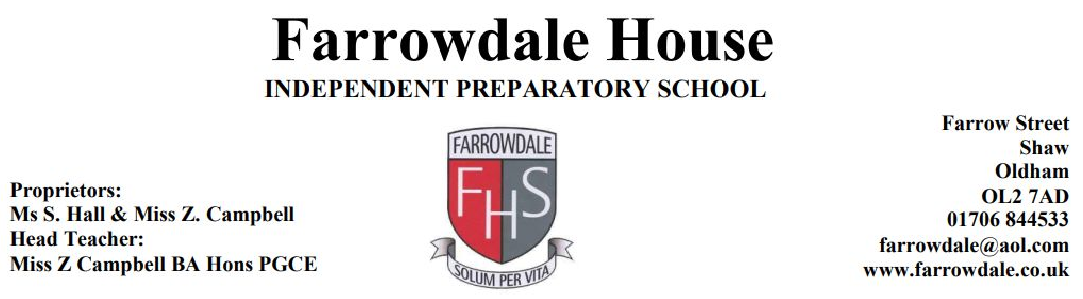
Equality and Diversity Policy
This policy applies to the whole school including EYFS

Introduction
Farrowdale House Independent School regards the diversity of the school community as a strength which enriches our school community.
All pupils at Farrowdale House have an equal right to develop and achieve their full potential. Equality of opportunity underpins the school curriculum and the work of the school. Children are treated as individuals with their own abilities, difficulties, attitudes, backgrounds and experiences. We recognise that all pupils are of equal worth regardless of cultural/ethnic background, religion, social circumstances, gender, ability and disability.
At Farrowdale House Independent School we aim for an atmosphere of trust and respect among children as well as between teachers and children. The children are taught about how we should treat each other and, more importantly, how we learn to respect one another and ourselves as citizens of the world. The school also fosters an understanding of the diversity of cultures and needs that exist in school and in the wider community.

Children
It is the right of every child irrespective of race, culture, class, gender, special needs or ability to achieve their full potential. Each child should have access to an education, which will enable him / her to utilise their talents to the full and achieve their potential. We must develop children to become sensitive to, and aware of, ways in which equality of opportunity is denied and how this might affect them in society.

Staff
It is the responsibility of all staff to foster and facilitate this ideal by creating a welcoming environment for all children. They will endeavour to establish an atmosphere within school which effectively reduces prejudice and raises self esteem, so that all children can develop independence, freedom of choice and a knowledge of their right to take on whatever roles they choose, no matter what their cultural background, gender or ability. As a staff we have to remember that we are role models. We must challenge the concept of discrimination based upon differences of race, gender and special needs. Aims
To ensure that:
- Every individual within the school achieves their full potential and has the same opportunities.
- Every child is given access to the best possible level of achievement appropriate to its age and ability through appropriately differentiated work.
- Prejudices are challenged and positive attitudes are built.
- Understanding and mutual respect of all children, regardless of differences, is promoted.
- Contributions from various cultures are included and acknowledged in the planning and teaching of the full range of National Curriculum subjects, resources and school displays, in order to prepare children for life in a culturally diverse society.
- An awareness of the unfairness and injustice of stereotyping is raised.
- Any form of bullying including verbal, physical and psychological bullying by any group or individuals is challenged and addressed.
- High levels of acceptable group and individual behaviour are promoted by ensuring that all the school community are informed of school expectations and procedures.
- Absences, racist incidents and bullying incidents are recorded and monitored.

Strategies used in school
Farrowdale House Independent School will use a range of methods to ensure all pupils have an equal right to develop and achieve their potential.
- Giving children time to talk in class discussions to give everyone opportunity to voice opinion and discuss how they are feeling.
- Encouraging the sharing of experiences - encompassing all equality issues.
- Reviewing/updating resources so that appropriate messages are presented to the children.
- Displays around school promoting positive equality issues.
- Staff on playground duty to identify loners, the assertive groups and any negative physical contact.
- Children encouraged to think about the exclusion of others and the negative effect it can have.
- Involving children in rulemaking in the classroom and also at a whole school level through the school council.
- Using positive praise and rewards for children to reinforce acceptable behaviour and attitudes.
- Sharing in various religious celebrations throughout the year

The Curriculum
All children will have equal access to all aspects of the curriculum and school life. We will need to monitor our practices to achieve this. Children should be given the opportunity:
- To gain self-worth and self-confidence, freeing them to develop a sense of who they are and what they want.
- To have equal educational experiences so that they can make appropriate choices from a base of common skills and knowledge.
The main objectives we are working towards are:
- To respect and value differences between people.
- To prepare pupils for life in a diverse society.
- To make the school a place where EVERYONE feels welcome and valued.
- To promote good relations between different racial and cultural groups within the school and the wider community.
- To ensure that an inclusive ethos is established and maintained.
- To acknowledge the existence of racism and take steps to prevent it.
- To be proactive in tackling and eliminating unlawful discrimination.

We will endeavour to:
- Raise awareness of the varying needs of others.
- Highlight and celebrate the differences between each other.
- Raise awareness of the need for appropriate facilities to be available for people with disabilities, e.g. wheel chair ramps.
This will be achieved through: appropriate discussions, topic links, e.g. work on the body, visiting speakers, appropriate resources, e.g. positive images in books/stories/displays and by following the inclusion policy.

Summary
All who work in school have a responsibility for promoting equality and inclusion, and avoiding unfair discrimination.
This policy will be regularly monitored and reviewed by staff and Proprietors to ensure that it is effective in tackling discrimination, promoting access and participation, equality and good relations between different groups, and that it does not disadvantage particular sections of the community
Reviewed August 2023

